

**B38EM**

**Lab1**

**Lab Report**

**Name: MA XUNCHI**

**HW ID:H00392669 XDU ID:21012100015**

1. **Introduction**

This lab is about understanding the concept of a microstrip transmission line and its behavior. The lab involves using Advanced Design System (ADS) to model a microstrip transmission line along with some lumped elements to generate S-parameters.

A typical microstrip transmission line is modeled on a substrate of FR4, which due to its low cost is a very commonly used substrate. FR4 is made up of composite material composed of woven fiberglass cloth with a flame-resistant epoxy material binding the structure. A thin layer of copper foil is laminated to both sides of it. The top side is the microstrip line while the bottom side is the ground plane. This foil is either milled or etched away to form the desired microstrip pattern and then connectors are soldered on.

1. **Lab activity**
2. Screen record of an ADS schematic, and 50 Ohm line calculation

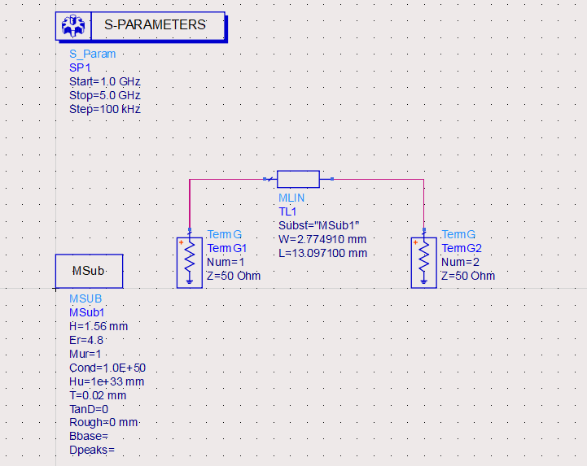

Figure 2.1.1 ADS schematic

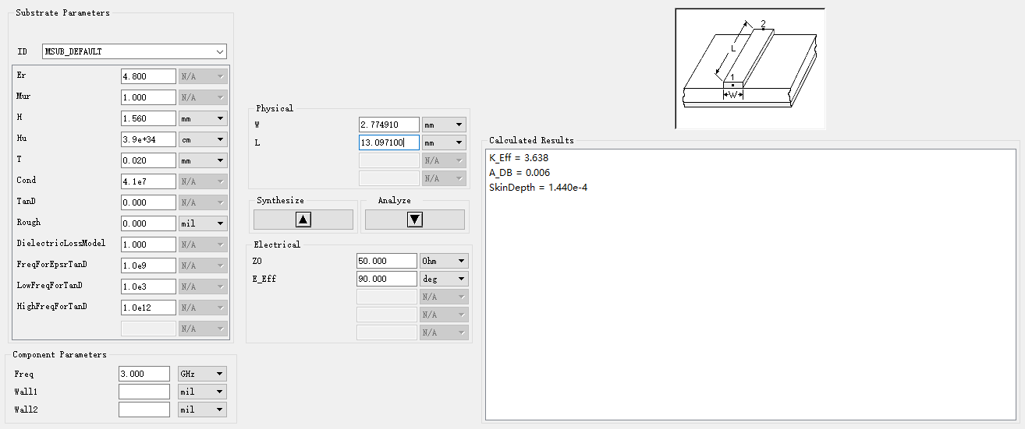

Figure 2.1.2 Line calculation result

2) Graph results of each parameter S11, S22, S12, S21 for Step 8

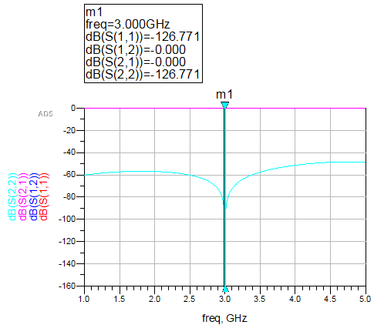

Figure 2.2.1 Results of S11, S22, S12, S21 for Step 8

3) Graph results of each parameter S11, S22, S12, S21 for Step 9

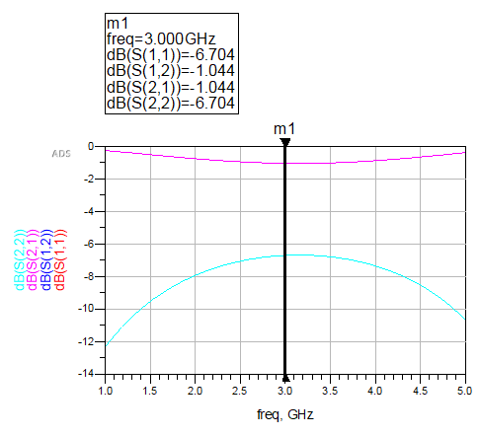

Figure 2.2.1 Results of S11, S22, S12, S21 for Step 9

1. **Exercises**
2. From the results obtained in Step 8, over which frequency range is our model accurate? Why do you think this is true?

* I think the frequency between 2.5 GHz to 3.4 GHz is accurate, cause the S11 in this range is so low (the reflection loss is so high) that the line and load is nearly matched. The reflected wave have little impact on the original wave

1. What might account for the differences between simulation and measurement results?

* The EM distortion in the space,
* the manufacturing work difference,
* the error caused by metering equipment.

1. From the results obtained in Step 9, calculate the Voltage Standing Wave Ratio of the microstrip line at 3 GHz.

Solution:

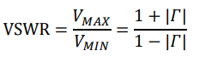

The calculation result is done by ADS and is show below:

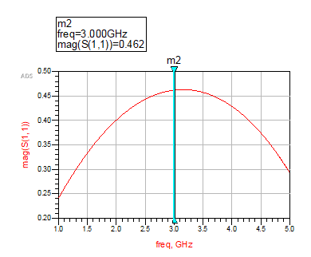

Figure 3.3.1 the magnitude of S11

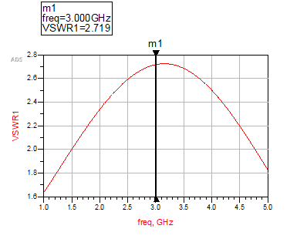

Figure 3.3.2 the value of VSWR